**Assignment 2 Javascript Essentials JAN 2021**

**Question 1** What is the value of clothes[0] and why? const clothes = ['jacket', 't-shirt']; clothes.length = 0; console.log(clothes[0]);

<!DOCTYPE html>

<html>

<head>

<title></title>

</head>

<body>

</body>

<script type="text/javascript">

const clothes = ['jacket', 't-shirt'];

clothes.length = 0;

console.log(clothes[0]);

</script>

</html>

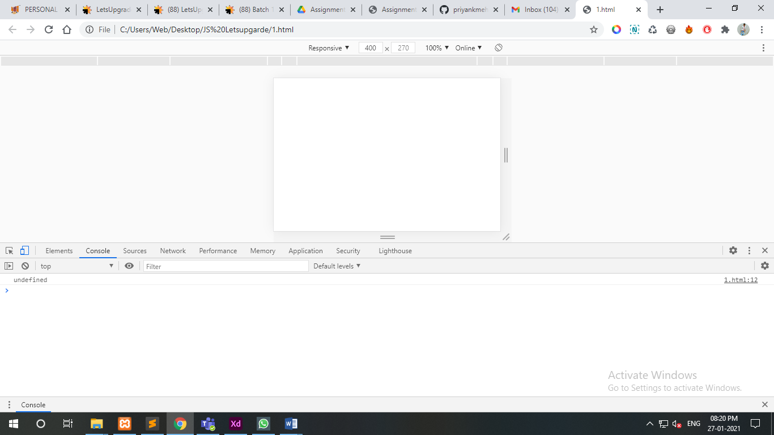

Because Const Variable use.

**Question 2** Write a Javascript program to find the sum of all elements of a given array?

<!DOCTYPE html>

<html>

<head>

<title></title>

</head>

<body>

</body>

<script type="text/javascript">

var array = [1, 2, 3, 4, 5, 6],

s = 0,

p = 1,

i;

for (i = 0; i < array.length; i += 1)

{

s += array[i];

p *= array[i];

}

console.log('Sum : '+s + ' Product : ' +p);</script>

</html>

